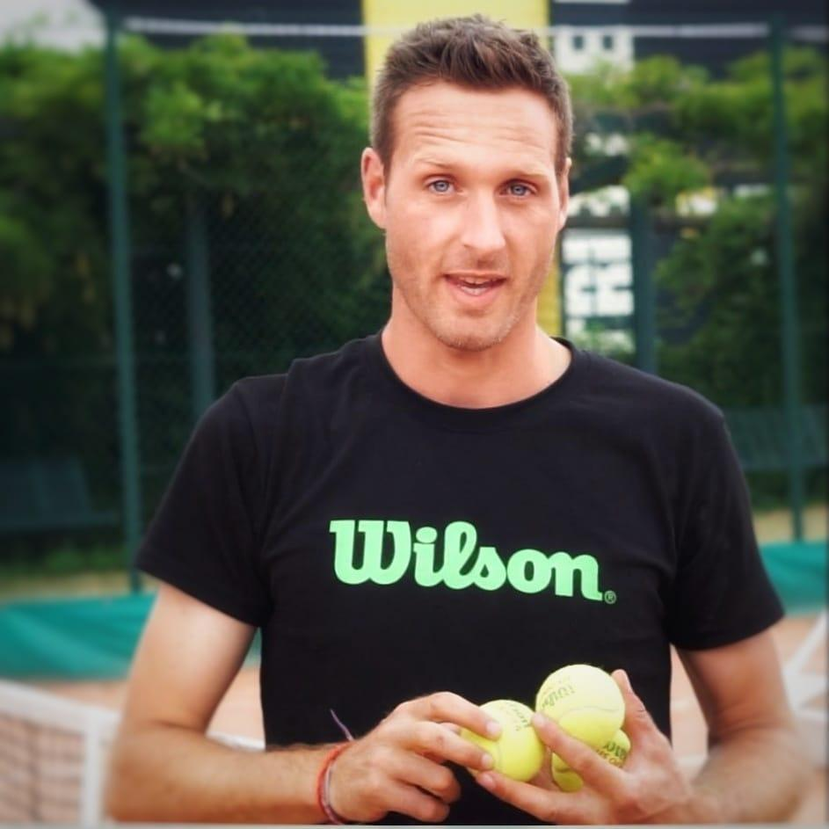

**Mathieu Coulon**

Age 38 years old

Best Ranking 3/6 in France

**Work experience**

May 2024 - Till now

**Tennis coach for my own in Alicante, Spain.**

May 2023 - May 2024

**Tennis coach at RC tennis pro with former**

**Director Ruben Ramirez Hidalgo**

**(ex : ATP 50) in Alicante, Spain.**

September 2020 - July 2021

**Head coach at Albi tennis club, France**

September 2019 - July 2020

**Tennis coach at SPTC,**

**Saint Pryvé saint mesmin, France**

Mars 2019 - July 2019

**Tennis coach at Victorian Tennis Academy**

**in Melbourne, Australia.**

January 2019 - July 2019

**Private tennis coach in Grand Hyatt hotel,**

**in Collins Street, Melbourne, Australia**

January 2017 - July 2019

**Tennis Coach in Yarraville, Australia**

January 2017 - April 2019

**Tennis coach at Port Melbourne**

**primary school in Melbourne, Australia**

October 2016 - January 2017

**Tennis Coach in Preston, Australia**

February 2015 - June 2015

**Tennis coach at Élite tennis**

**academy in Coburg, Australia**

November 2014 - February 2015

**Tennis Coach at top tennis academy**

**in Malvern East, Melbourne, Australia**

November 2014 - February 2015

**Tennis coach at Elsternwick tennis**

**academy in Brighton, Australia**

September 2013 - June 2014

**Private tennis coach for the**

**Rothschild Family near Paris, France**

September 2013 - June 2014

**Tennis coach in Chateaurenard, France**

September 2013 - June 2014

**Head coach in Marigny les Usages, France**

July - August 2013

**Head coach in La Plagne, France**

September 2013 - June 2014

**Head coach, in Communay, France**

July - August 2014

**Head coach in La Plagne, France**

Juin 2013

**Tournament coaching at L’open**

**de l’adour in Dax, France (U10)**

March 2013

**Tournament coaching in Pays de**

**la Loire league, Angers, France (U10)**

September 2011 - June 2012

**Head coach in Marigny Les usages, France**

July - August 2011

**Head coach at Pierre & vacances resort**

**in Deauville, France**

April 2011

**Head coach at Pierre & Vacance resort**

**in Cap Esterel, France**

September 2010 - June 2011

**Tennis coach in Sully sur Loire, France**

July - August 2010

**Tennis coach in l’Ile Rousse, Corsica, France**

September 2009 - June 2010

**Tennis coach in Montargis, France**

September 2008 - June 2009

**Trainee for specific tennis skills in**

**Lagny sur Marne, France**

September 2005 - June 2007

**Sport trainee & Tennis partner**

**of Caroline Garcia in Villeurbanne, France**

**STATE DIPLOMA IN TENNIS**

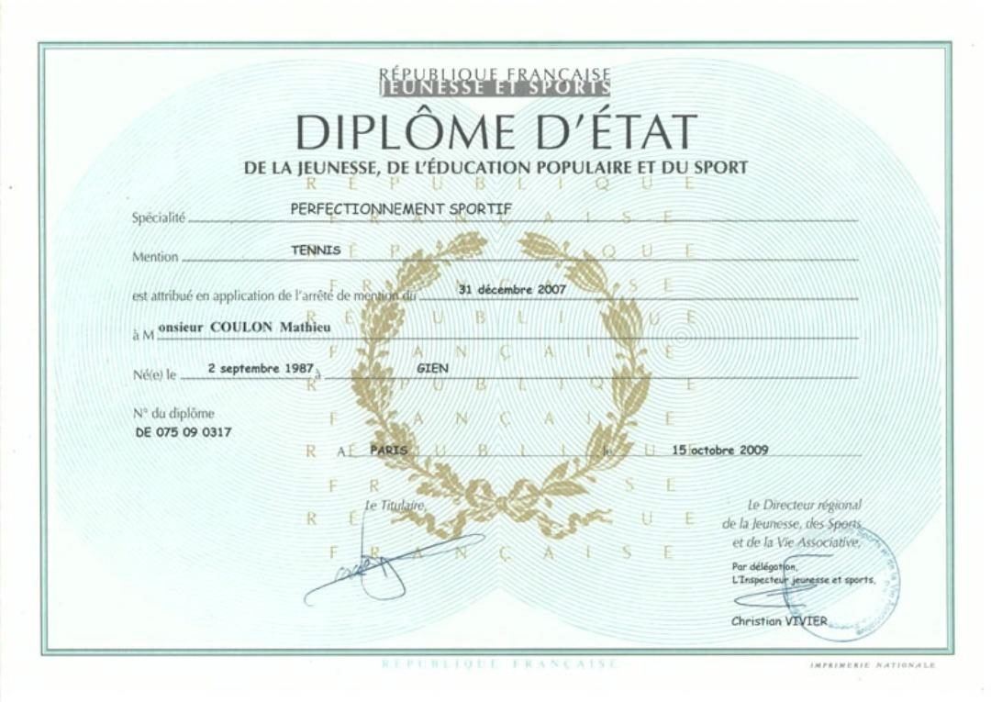

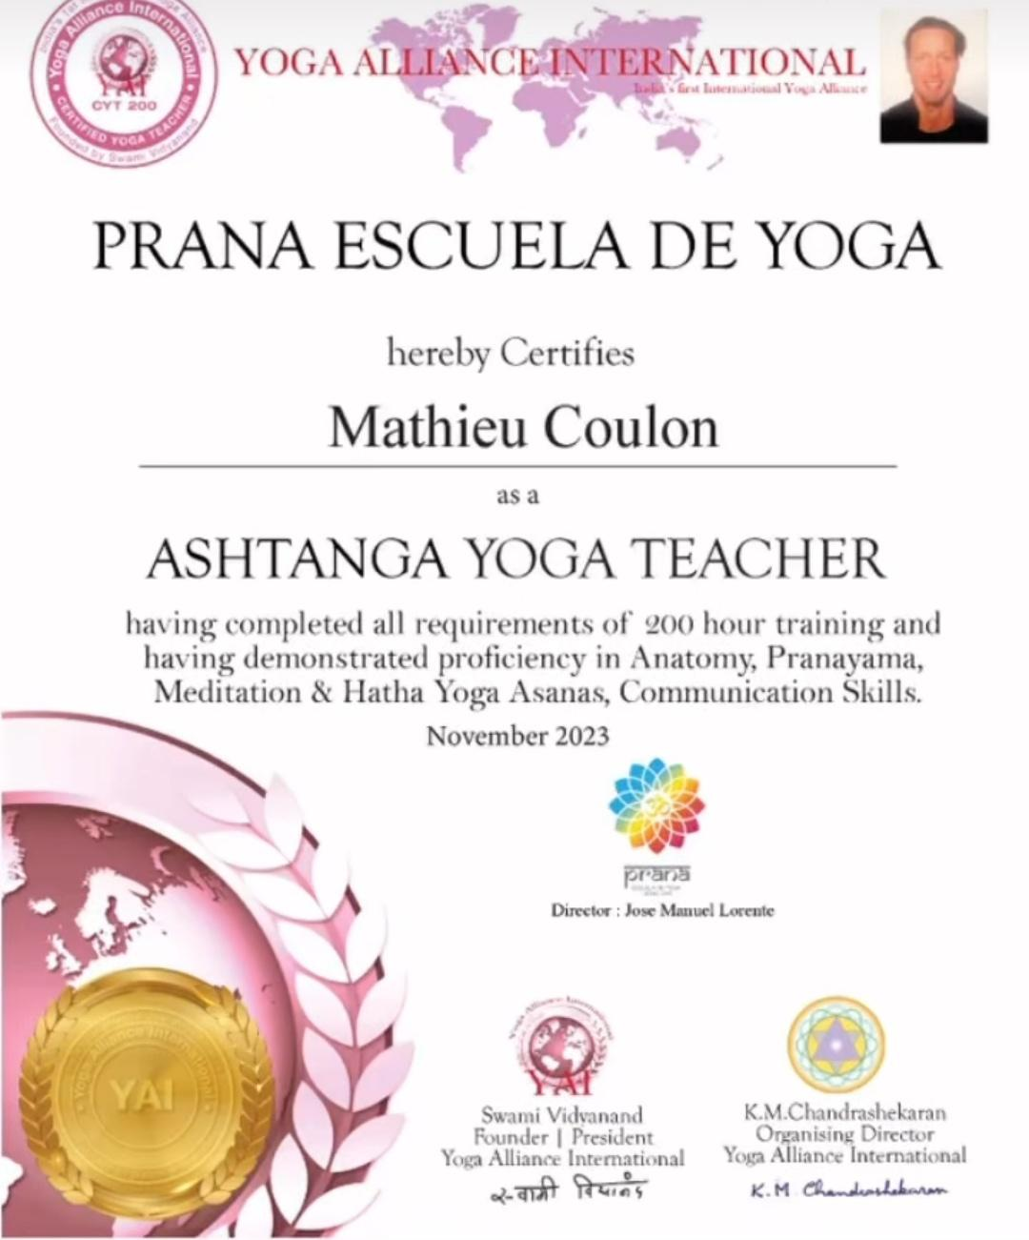

**ADDITIONAL SKILLS**

**Languages**

French/English/Spanish

**Extra**

Références from President of Albi tennis club

**Personal Qualities**

PASSIONATE - RESILIENT - ADAPTABLE

